Kolavo Homepage and Daftar Anggota Messaging

Users
- Primary
- Visitors
- Secondary
  - Admin
  - Member
Intended Outcome
- Visitors understand what Kolavo is at the first glance
- Admin and member know what to do when they are in Daftar Anggota Page
Links
- …
- …
- …
- …
- …

Introduction
Messaging at the first app page is very important as it can make or break the mood of using the app. Currently leads agree with the problem of WhatsApp Group cannot be used for connecting with members and Kolavo can be its solution. However, the messaging at the first page did not do enough to invite leads to continue registering and so on and so forth. Hence, it is important to update the messaging to increase the feel and urgency to use Kolavo.

Product Requirement
No | User story | Scope | Acceptance Criteria
1 | As a visitor, I want to understand the urgency of using Kolavo, so I am triggered to use it. | Copy and picture at home page | - Showing heading and description where komunitas word rapidly change to organisasi, asosiasi, ikatan alumni, and himpunan.  - The komunitas word has a different color than the other words.  - Showing whatsapp group picture
2 | As admin/member, I want to understand what I can do when accessing the Daftar Anggota page, so I can do so. | Copy of Daftar Anggota | - Showing description the best practice of using the Daftar Anggota page

Design Requirement

Copy
Design Intent | To catch visitors attention and help them to understand what can they use Kolavo for
Content / Copy | - Heading:  Tau anggota komunitas,  Tanpa kenalan di WAG.  - Description  ✅ Mudah membangun relasi waktu ketemu pertama kalinya  ✅ Cepat menemukan calon mentor pengembangan diri  ✅ Percaya kolaborasi usaha ataupun mempekerjakan anggota  Temukan dan bergabung ke komunitas atau buat yang baru dan ajak anggotamu untuk bergabung, biar bisa saling kenal.  - Komunitas word both on Heading and Description change to  - organisasi  - asosiasi  - ikatan alumni  - himpunan
Visual Requirement | - Komunitas words changing at the 3rd seconds  - Komunitas and other changing words color is #ff6b35  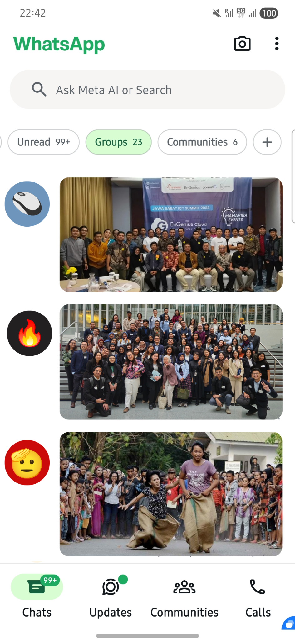  - Picture  - Border 000000  - Corner radius 10  - Border weight 1  - Rotate as shown in Figma
Interaction Behavior
Acceptance Criteria

Copy Deskripsi Daftar Anggota Page
Design Intent | To guide admin/member so they know what to do in the page
Content / Copy | - Description:  Lihat siapa saja yang ada disini. Klik kategori dan pilih filter yang ada, atau klik tag di profil untuk langsung filter anggota. Klik profil anggota untuk lihat komunitas apa saja yang mungkin kamu bisa gabung.
Visual Requirement
Interaction Behavior
Acceptance Criteria

Engineering Requirement

Questions

